
Tunisian-Japanese Company of Electronics SOTUNEC SARAYA
PRESENTATION OF THE COMPANY :
Since 2014, SOTUNEC SARAYA has been working on the Internet of Things applied in different fields such as:
- Public lighting
- Smart houses
- Oil
- Hospitals
- The hotel industry
- The roads
With the aim of saving energy and offering comfort to the user by applying artificial intelligence.
Founded in 2014 by 21 year old Emna Ben Ali, SOTUNEC SARAYA has started winning awards and trophies such as:
- National award for the best business plan Tunisia 2015
- Tunisia Innovation Award 2015
- Trophy of the woman entrepreneur of Tunisia 2018
- African and Arab Countries Award for Best Green Startup Tunisia/Lebanon 2018
- Best project financed by BTS Tunisia 2022
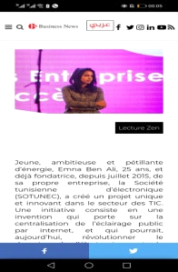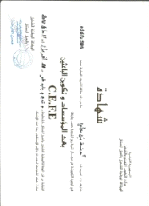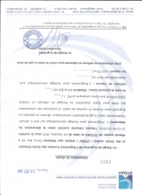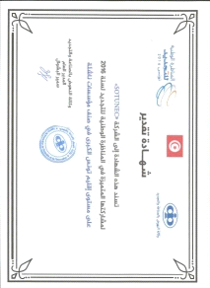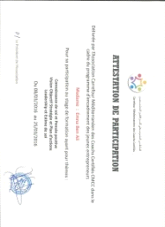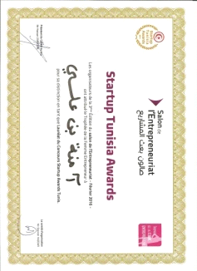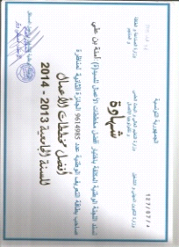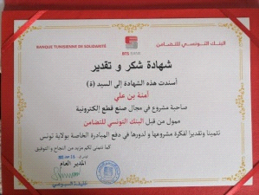

SOTUNEC SARAYA also owns 6 brevets for inventions (2016/2016/2020/2022/2022/2022).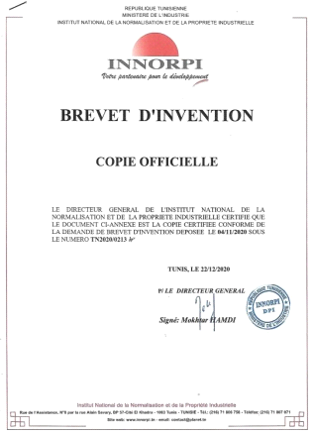
Recognized in the Arab and African world, SOTUNEC SARAYA has a very strong relational network in African, Arab and Gulf countries.
With the help of its team of professional engineers, its SMART products have been very successful especially in recent years as energy saving is the primary concern of governments. The solution of public lighting has been successful in Tunisia and Africa, which encouraged the founders of SOTUNEC SARAYA (Tunisians and Japanese) to start manufacturing electronic cards in large series, high quality and aimed at all fields.
SOTUNEC SARAYA PRODUCTS :
- Remote management system for public lighting :

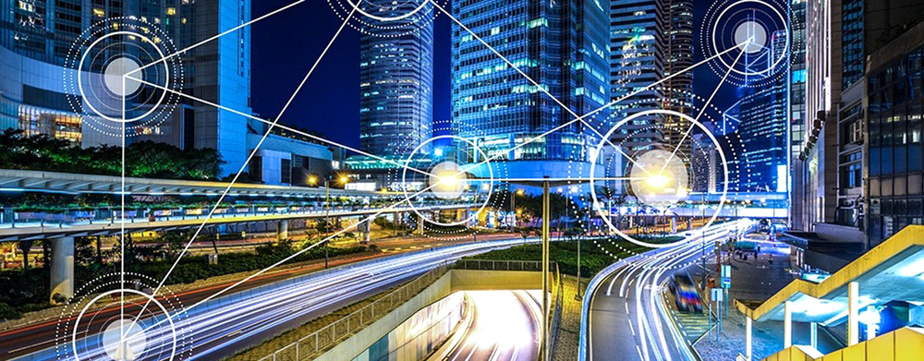

- The remote management system for street lighting is used to control and monitor the network remotely and to save up to 70% of energy consumption.

This system communicates via GSM/GPRS/WIFI/CPL/RF/LORA according to the user's needs and depending on the study and free diagnosis of the intervention area and the reliability of the network.

This system is universal, it can be installed in all types of luminaires (LED SODIUM HPL etc.)

NB: the dimming option is only valid in LED luminaires, in case of existence of other type, it can be replaced by switching on point by point or point on 2 points.

This system consists of two parts:

- HARD part :

The HARD part is equipped with a SMART three-phase energy meter, a MASTER niche and smart switches.

SMART energy meter :

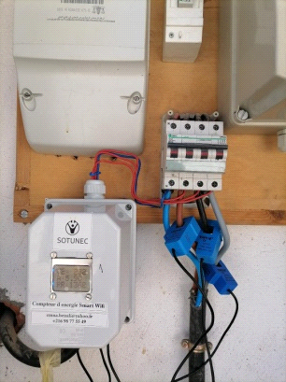

It is a system for measuring consumption, current, voltage, active power, reactive power, apparent power, power factor cos PHI, and 60 other quantities.
This energy meter is three-phase, communicating via GSM/GPRS/WIFI/CPL/RF/LORA.
Equipped with an LCD display, RS485 port the energy meter can detect anomalies at the distribution station.

MASTER Niche :

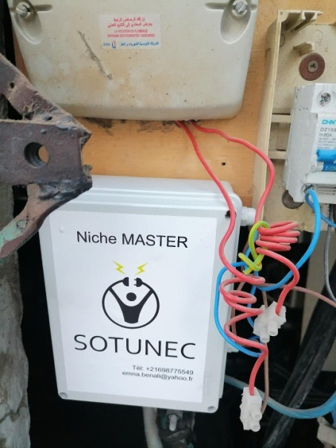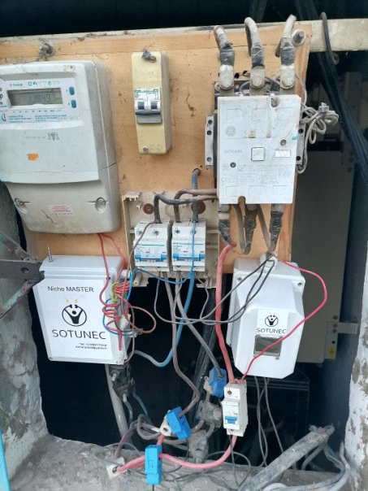

It is the brain of the whole system, the MASTER niche is used to collect information from the smart switch, gateway, energy meter and send it to the server and store it.
The MASTER kennel is equipped with an anti-theft system, which contains a camera, which triggers and takes a video if the kennel is opened by an unknown person.

Smart Switch :

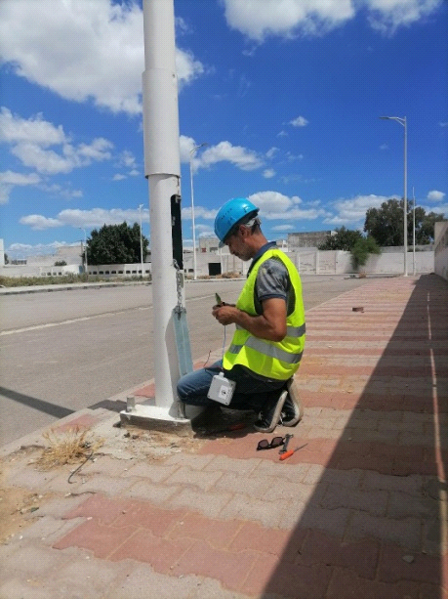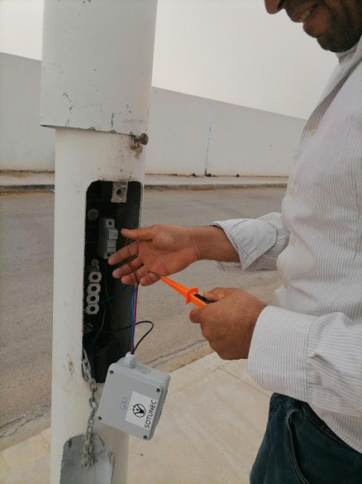

It is the brain added to each luminaire to make it SMART and communicative.
It is a small box that acts as a remote-controlled SMART switch.
This SMART Switch is used to communicate with the GATEWAY to send, receive and execute information received by the user.
In the end, you could say that the SMART Switch is a public lighting agent that monitors each luminaire 24/7!
It is available in GSM/GPRS/WIFI/CPL/RF/LORA.

Gateway :

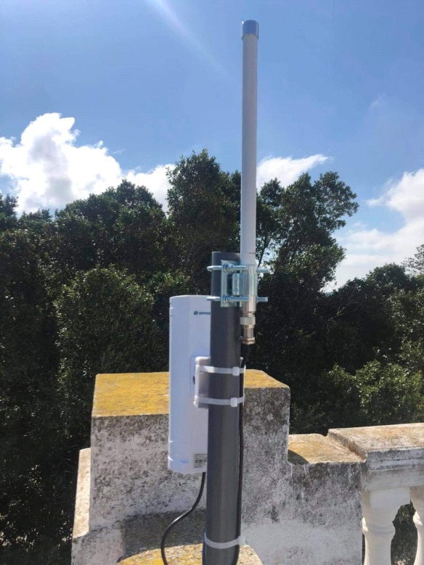

This is the organ that is responsible for covering the surface in connectivity.
Our Gateways can reach a 10km radius of connectivity, which provides us with a smart city infrastructure that will lead us in the future to connect traffic lights

public transport, ambulances, irrigation systems, and any other systems that need to be controlled remotely.
Indeed, the remote management system for street lighting will itself be the infrastructure of a smart city.

- SOFT part :

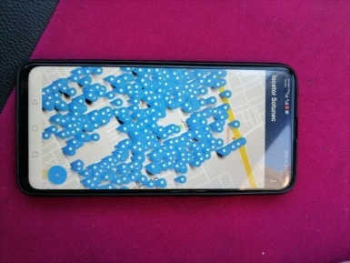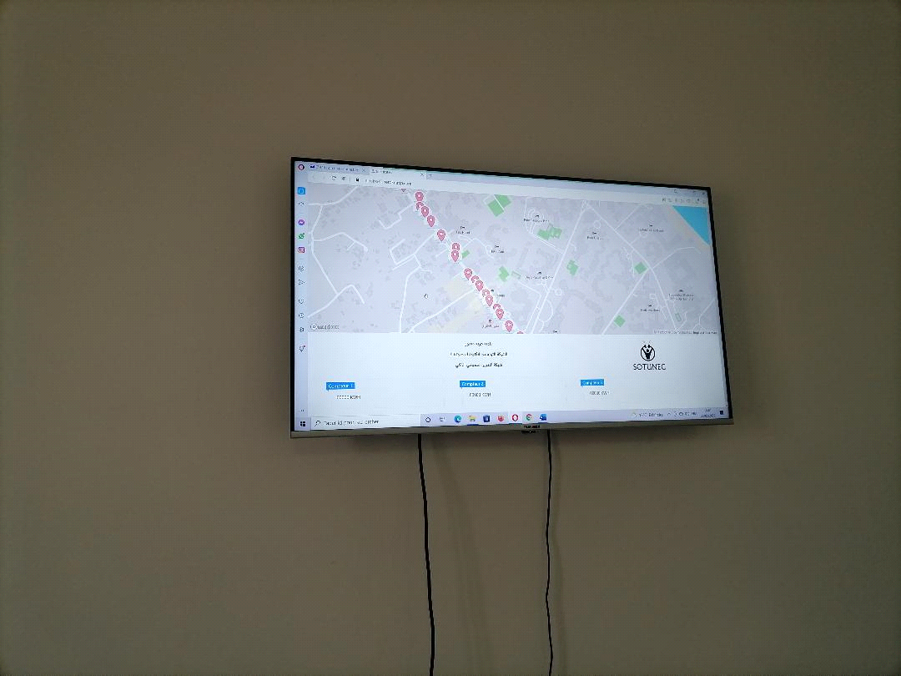

It is a platform applicable on computer, tablet or Smartphone
This platform contains a digital map (MAP), which contains the location of each luminaire with its status updated in real time.
If the light is on, the colour will be GREEN, if it is off, the colour will be RED, and if it is out of order the colour will be flashing YELLOW.
Also by clicking on the location of the luminaire, the information of the latter is automatically displayed such as (type of luminaire SODIUM, LED, HPL etc... date of installation, date of last maintenance etc...)
A bar containing the energy meter readings for each distribution station is displayed with the most important values (consumption, power, current, power factor voltage etc.)
A programming bar for programming the personalised operation of the public lighting network, e.g. (switch on 30 minutes after sunset, decrease the brightness to 30% from 00:00 to 3:00, increase the brightness to 70% from 3:00 to 5:00, and to 100% from 5:00 to sunrise)

- SMART TRAFFIC LIGHT MANAGEMENT SYSTEM :

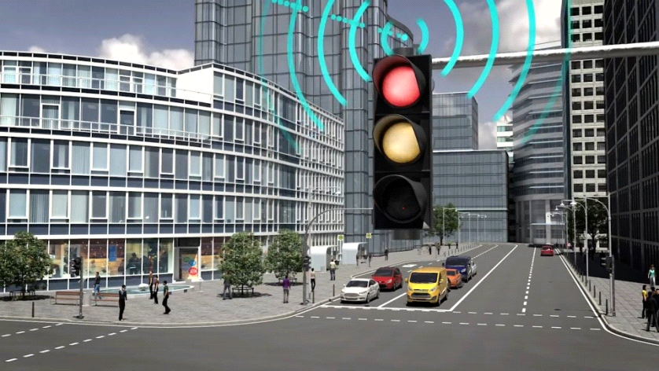

It is a box that serves to control the traffic lights automatically and to supervise them remotely as well as to change the programming remotely.
- Full priority for ambulances.
- Car flow detection and automatic programming according to the recorded values.
- Counter output for 7seg /LCD display.
- No need to go to the kennel to change the program, everything is managed remotely.

- FUEL MEASUREMENT SYSTEM FOR TANKS :

This system has been very successful, it is used to monitor the fuel level (petrol, diesel, LPG), remotely and display it in real time on the service point manager's computer.
It contains a very high security RADAR sensor, and works with an artificial intelligence method.

The user sets a safety threshold not to be exceeded, if the fuel level decreases and reaches this safety threshold, a notification on the application accompanied by an SMS on the manager's phone indicating the tank to be filled and the type of fuel.
At the headquarters or supply centre, there will be a control room containing a MAP, on which the service points will be displayed in their locations.
Clicking on one of the service points will show the tank information, levels and notifications (if any).

Example: Company X service point RADES tank 3 Diesel 200L (2200L requirement)
Then, if the safety threshold is reached, an automatic telephone call will be made to the supply centre linked to the area where the service point is located to indicate the lack of fuel, accompanied by an SMS containing the information and a notification in the control room at headquarters.

- TEMPERATURE MEASUREMENT SYSTEM FOR HOSPITALS :

This is a system for remote measurement of the ambient temperature in centrifuges (for analytical laboratories), in refrigerators, and in server rooms.
A control room that contains computers, where a platform will be located that will contain all the information, history and alerts.
Generators can also be controlled because of their importance in hospitals.

- GPS TRACKING :

It is a vehicle tracking system with the option to stop the vehicle remotely and control the fuel.


- SMART HOME :

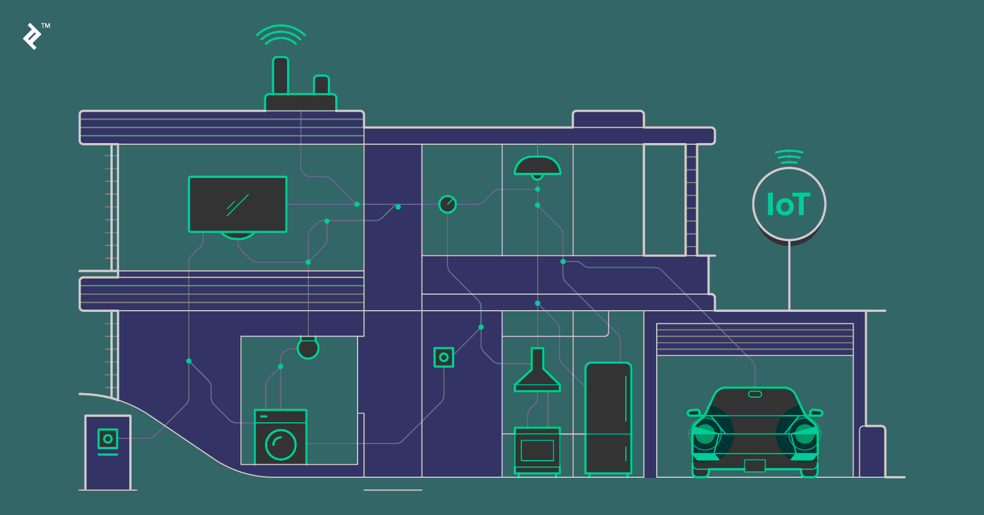

These are SMART Switches for controlling and monitoring all the equipment in the home such as (lighting, air conditioners, ovens, televisions, refrigerators, blinds etc.)
It is available in GSM/GPRS/WIFI/CPL/RF/LORA.
Programming can be done by the user, for example:
At 4.30pm (before arriving home 15min) turn on the air conditioning, close the blinds and turn on the oven and TV.

- SMART INDUSTRY :

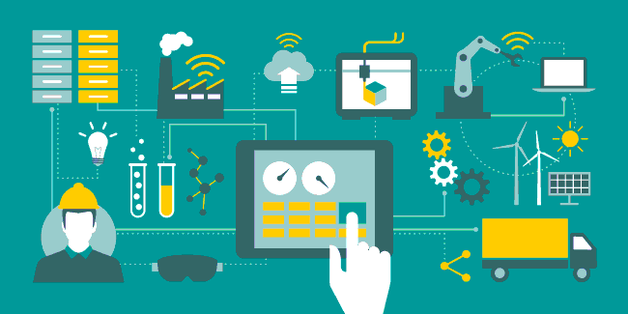

This system is for factories that want to optimise their energy consumption as well as control their production remotely.

- SMART BUILDING (FOR HOTELS AND OFFICES) :

These are the remote-controlled SMART Switches, equipped with a presence sensor, which turn on the lighting or air conditioning only if someone is in the room or office.
Possibility to control and supervise remote equipment as well as energy meters and their measurements.
This system helps offices and hotels to save more than 50% of energy and reduce their electricity bill.
ELECTRONIC CARD MANUFACTURING PLANT :
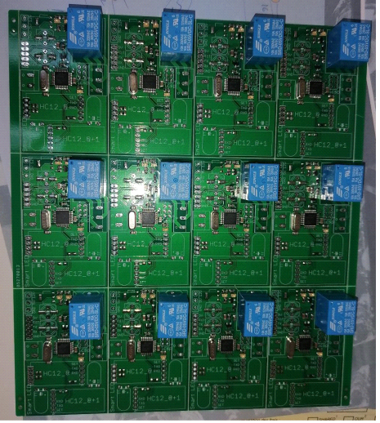
At the beginning of 2023, SOTUNEC SARAYA will start the production of electronic cards with a large high-end production capacity (more than 1000 units per day)
We also offer our services to all companies needing subcontracting in the manufacture of PCBs.

Tunisian-Japanese Company of Electronics SOTUNEC SARAYA
+216 98 77 55 49
Whatsapp: 216 26 96 93 08
Emna.benali@sotunec.net
www.sotunec.net

